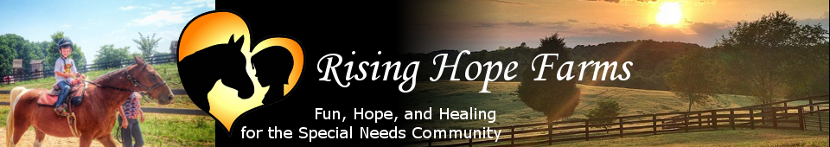

You Can Drive Clinic & Fund Raiser



**May 9, 2015 – 10:00-11:30 a.m.**

**Donation: $25 cash / check**

If you love horses and would like to learn more about using horses to pull carts and carriages, then come join us for a driving clinic at ***Rising Hope Farms***.

The Clinic will demonstrate how to harness horses that range from minis to drafts. We will discuss safety, different types of harnesses and carriages. You will have the opportunity to ask questions, ride on a carriage, or possibly drive.

For an additional $5 donation, you can take part in the “***hands on****”* portion where you can work with club members to harness horses, ride and possibly drive.

All proceeds go to support ***Rising Hope Farms***.

To register for the driving clinic call:

Geri Shea @ 828-459-1820 or email @: [gshea@itwx.com](mailto:gshea@itwx.com)

Woody Woodall@ 704-883-6390 or email @: [wdbluewater117@aol.com](mailto:wdbluewater117@aol.com)

Clinic location: 3775 Bethany Church Rd., Claremont, NC 28610

[www.RisingHopeFarms.com](http://www.RisingHopeFarms.com) [www.whipsandwheels.com](http://www.whipsandwheels.com)